**CAED LAB 05**

**EXERCISES**

***HAMZA AHMED SIDDIQUI***

***FA17-BECE-0026***

Q1: Evaluate the following MATLAB expressions. Where i,j,k and l have the following values:

1. i*j + k*l

2. i*(j+k)*l

3. (i*j) + (k/l)

4. (i+j) * i^j

**Result:**

1.

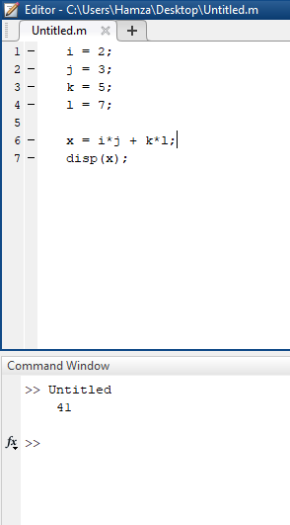

2.

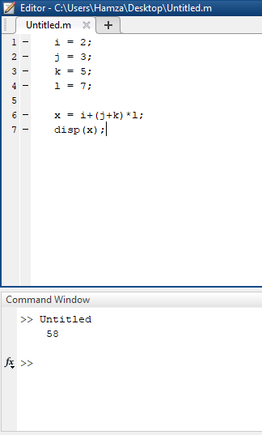

3.

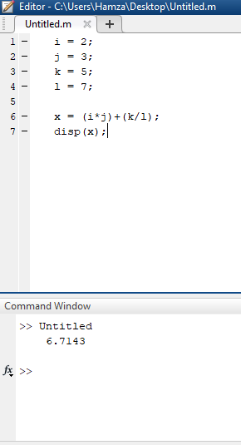

4.

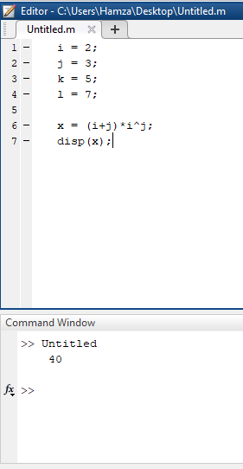

Q2: Evaluate the following MATLAB expressions. Where x = 3-4i and y=1+2i.

1. X + y

2. X – y

3. X * z

4. x/y

5. X power y

**Result:**

1.

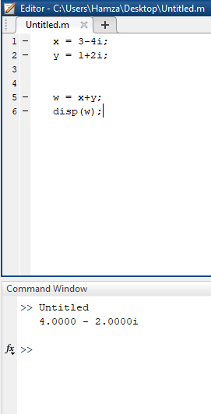

2.

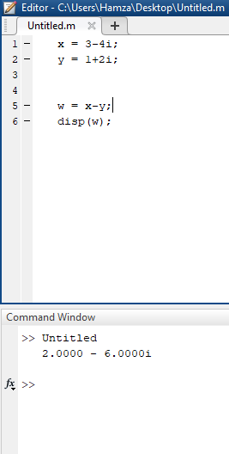

3.

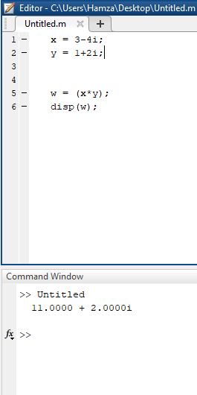

4.

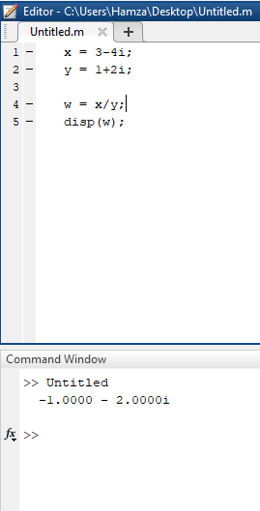

5.

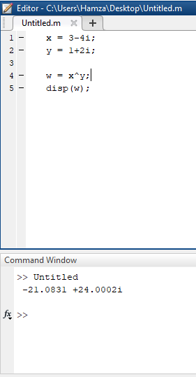

Q3: Write a program to solve Quadratic Equation in MATLAB.

**Result:**

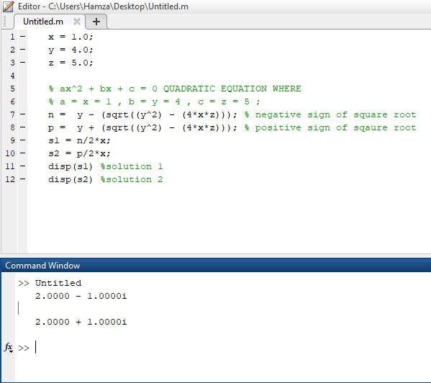

Q4: Write a program to solve Distance formula in MATLAB.

**Result:**

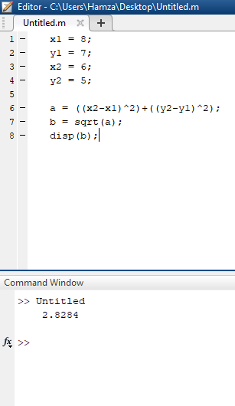

Q5: Write a program to solve mid-point in MATLAB.

**Result:**

